**Art Gallery Database Modeling**

**Final Report**

**Group: Mister Freeze**

**Group Members:**

**Xuejun Shen, Bingyue Zeng**

**Xiao Xue, Zengpu Wang**

**Professor: RP Raghupathi**

**Date: 12/04/2019**

**Part A.**

1. **Entity Relationship Diagram**

**Entity Relationship Diagram for Art Gallery**

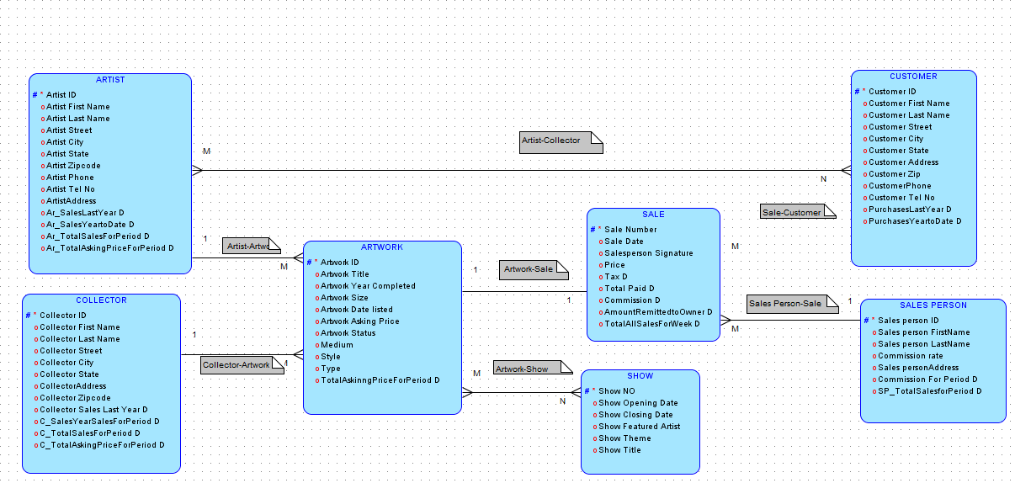

1. **Data Dictionary for Entity Relational Model**

|  |  |  |
| --- | --- | --- |
| **Attribute / Entity Name** | **Unique Identifier** | **Data Type** |
| **Entity: ARTIST** |  |  |
| Artist ID | **Identifier** | VARCHAR2(4000) |
| Ar_SalesLastYear D |  | NUMBER |
| Ar_SalesYeartoDate D |  | NUMBER |
| Ar_TotalAskingPriceForPeriod D |  | NUMBER |
| Ar_TotalSalesForPeriod D |  | NUMBER |
| ArtistAddress |  | VARCHAR2(4000) |
| Artist City |  | CHAR |
| Artist First Name |  | CHAR(20) |
| Artist Last Name |  | CHAR(20) |
| Artist Phone |  | NUMBER |
| Artist State |  | CHAR |
| Artist Street |  | VARCHAR2(4000) |
| Artist Tel No |  | NUMBER |
| Artist Zipcode |  | NUMBER |
| **Entity: ARTWORK** |  |  |
| Artwork ID | **Identifier** | VARCHAR2(4000) |
| Artist ID |  | VARCHAR2(4000) |
| Artwork Asking Price |  | NUMBER(20,2) |
| Artwork Date listed |  | DATE |
| Artwork Size |  | VARCHAR2(10) |
| Artwork Status |  | VARCHAR2(4000) |
| Artwork Title |  | VARCHAR2(4000) |
| Artwork Year Completed |  | NUMBER(4,0) |
| Collector ID |  | VARCHAR2(4000) |
| Medium |  | CHAR(20) |
| Sale Number |  | NUMBER(38,0) |
| Style |  | CHAR(400) |
| TotalAskingPriceForPeriod D |  | NUMBER |
| Type |  | CHAR(20) |
| **Entity: COLLECTOR** |  |  |
| Collector ID | **Identifier** | VARCHAR2(4000) |
| C_SalesYearSalesForPeriod D |  | NUMBER |
| C_TotalAskingPriceForPeriod D |  | NUMBER |
| C_TotalSalesForPeriod D |  | NUMBER |
| CollectorAddress |  | VARCHAR2(4000) |
| Collector City |  | CHAR(20) |
| Collector First Name |  | CHAR(20) |
| Collector Last Name |  | CHAR(20) |
| Collector Sales Last Year D |  | NUMBER |
| Collector State |  | CHAR(20) |
| Collector Street |  | VARCHAR2(4000) |
| Collector Zipcode |  | NUMBER |
| **Entity: CUSTOMER** |  |  |
| Customer ID | **Identifier** | VARCHAR2(4000) |
| Customer Address |  | VARCHAR2(4000) |
| Customer City |  | CHAR(20) |
| Customer First Name |  | CHAR(20) |
| Customer Last Name |  | CHAR(20) |
| CustomerPhone |  | NUMBER |
| Customer State |  | CHAR(20) |
| Customer Street |  | VARCHAR2(4000) |
| Customer Tel No |  | NUMBER |
| Customer Zip |  | NUMBER |
| PurchasesLastYear D |  | NUMBER |
| PurchasesYeartoDate D |  | NUMBER |
| **Entity: SALE** |  |  |
| Sale Number | **Identifier** | NUMBER(38,0) |
| AmountRemittedtoOwner D |  | NUMBER |
| Artwork ID |  | VARCHAR2(4000) |
| Commission D |  | NUMBER |
| Customer ID |  | VARCHAR2(4000) |
| Price |  | CHAR(1000) |
| Sale Date |  | DATE |
| Salesperson Signature |  | BLOB |
| Sales person ID |  | VARCHAR2(4000) |
| Tax D |  | NUMBER |
| TotalAllSalesForWeek D |  | NUMBER |
| Total Paid D |  | NUMBER |
| **Entity: SALES PERSON** |  |  |
| Sales person ID | **Identifier** | VARCHAR2(4000) |
| Commission For Period D |  | NUMBER |
| Commission rate |  | NUMBER |
| Sales personAddress |  | VARCHAR2(4000) |
| Sales person FirstName |  | CHAR(20) |
| Sales person LastName |  | CHAR(20) |
| SP_TotalSalesforPeriod D |  | NUMBER |
| **Entity: SHOW** |  |  |
| Show NO | **Identifier** | VARCHAR2(4000) |
| Show Closing Date |  | DATE |
| Show Featured Artist |  | CHAR(100) |
| Show Opening Date |  | DATE |
| Show Theme |  | CHAR(100) |
| Show Title |  | CHAR(100) |

1. **Assumptions For E-R Logical Model**
2. Ar_SalesLastYear D, Ar_SalesYeartoDate D, Ar_TotalSalesforPeriod D, and Ar_TotalAskingPriceforPeriod D are descriptive attributes between Entity ‘Artwork’ and Entity ‘Artist’.
3. Collector Sales Last Year D, C_SalesYearSalesforPeriod D, C_TotalSalesForPerio D, and C_TotalAskingPriceforPeriod D are descriptive attributes between Entity ‘Collector’ and Entity ‘Artwork’
4. TotalAskingPriceforPeriod D，Tax D, Total Paid D, AmountRemittedtoOwner D, and TotalAllSaleforWeek D are descriptive attributes between Entity ‘Artwork’ and Entity ‘Sale’.
5. Commission D, Commission for Period D, and SP_TotalSalesforPeriod D are descriptive attributes between Entity ‘Sale’ and Entity ‘SalePerson’.
6. PurchaseLastYear D and PurchasesYeartoDate D are descriptive attributes between Entity ‘Customer’ and Entity ‘Sale’.
7. TotalAskingPriceforPeriod D = Ar_TotalAskingPriceforPeriod D + C_TotalAskingPriceforPeriod D
8. **NOTE**: Attribute ‘Price’ does not include tax or tax rate, so we decide that it is eligible for ‘Price’ to be a normal attribute inside Entity ‘Sale’.
9. A show may have many featured artists.
10. An artwork may be presented in many shows and one show may present many artworks.
11. An artist may contact with many customers and a customer may get in touch with many artists.

**Part B.**

1. **Default Relational Model**

**Default Relational Model for Art Gallery**

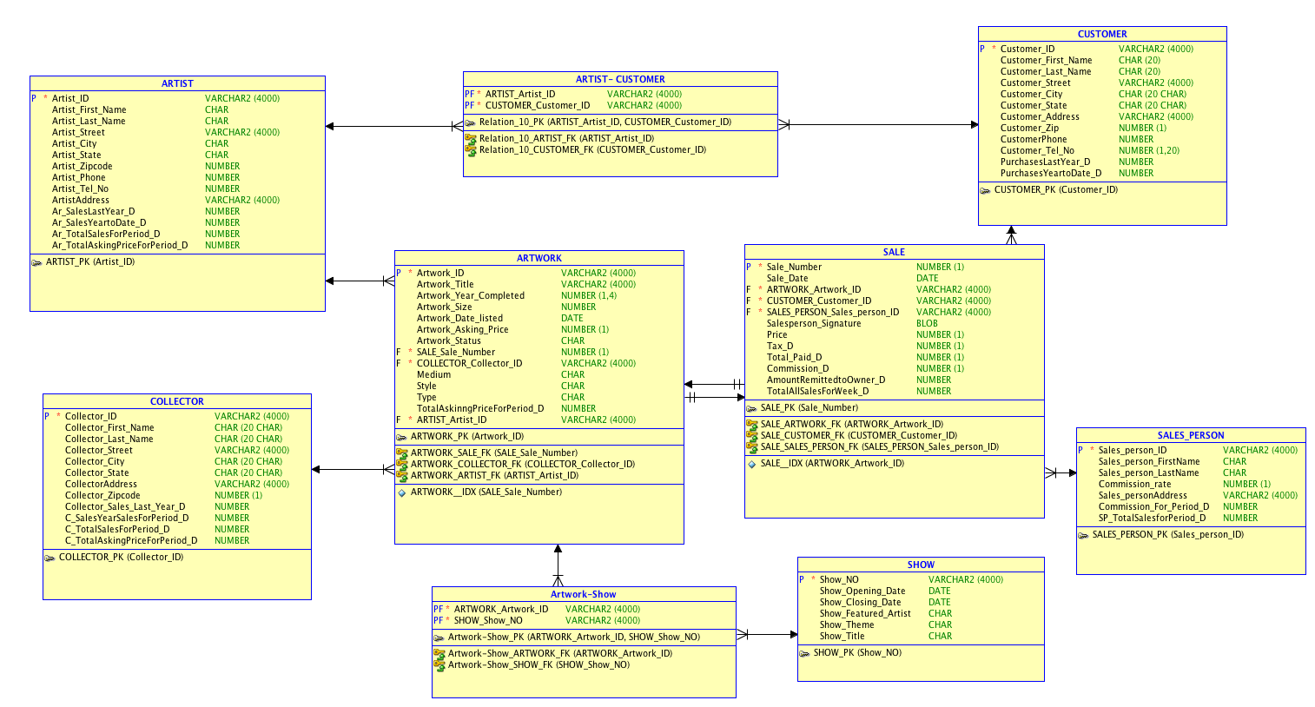

1. **Revised Relational Model**

**Revised Relational Model for Art Gallery**

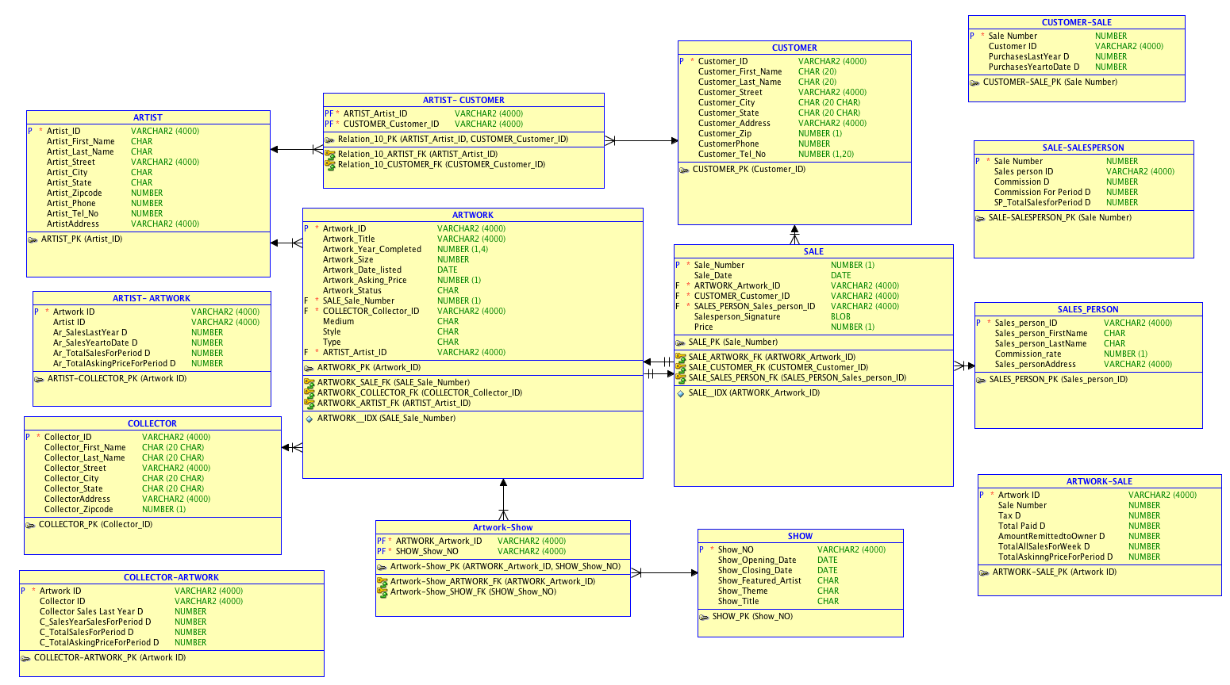

1. **Normalized Relational Model**

**Normalized Relational Model for Art Gallery**

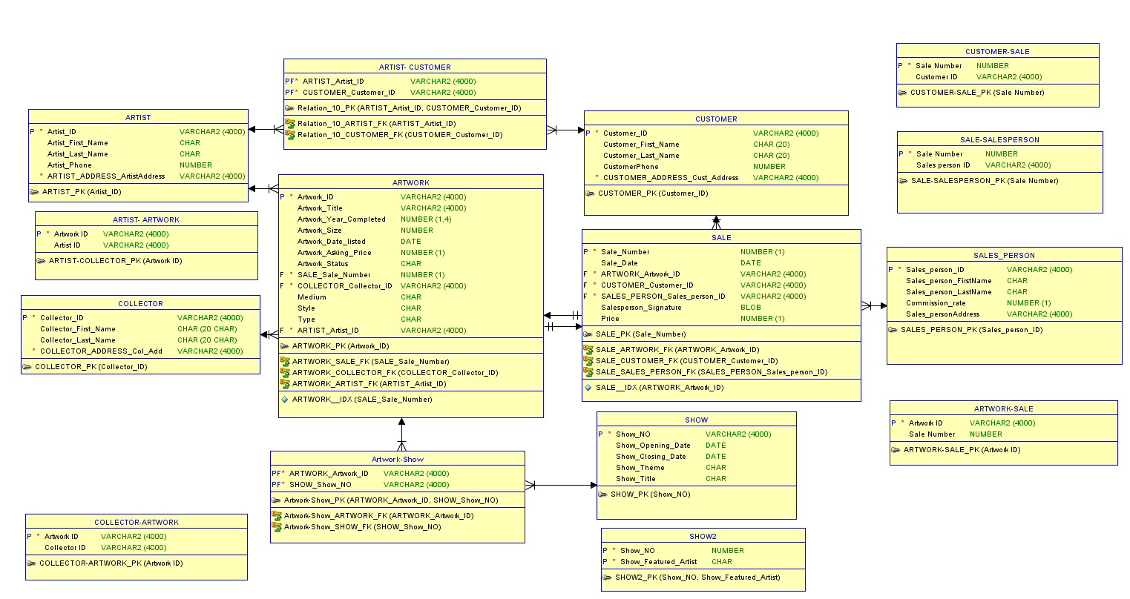

1. **Assumptions for normalized PDM**
2. Total Paid = Price* (1+Tax). Note: Tax refers to tax rate.
3. Amount Remitted to Owner = 0.9*(Price) - Commission_rate*Price. Note: Commssion_rate is the rate which we assumed the gallery splits the salesperson with.

**PART C.**

1. **DDL Script:**

CREATE TABLE artist (artist_id VARCHAR2(4000) NOT NULL,

artist_first_name CHAR ,

artist_last_name CHAR ,

artist_phone NUMBER,

artist_address_artistaddress VARCHAR2(4000) NOT NULL);

ALTER TABLE artist ADD CONSTRAINT artist_pk PRIMARY KEY ( artist_id );

CREATE TABLE "ARTIST- ARTWORK" ("Artwork ID" VARCHAR2(4000) NOT NULL,

"Artist ID" VARCHAR2(4000));

ALTER TABLE "ARTIST- ARTWORK" ADD CONSTRAINT "ARTIST-COLLECTOR_PK" PRIMARY KEY ( "Artwork ID" );

CREATE TABLE "ARTIST- CUSTOMER" ( artist_artist_id VARCHAR2(4000) NOT NULL,

customer_customer_id VARCHAR2(4000) NOT NULL);

ALTER TABLE "ARTIST- CUSTOMER" ADD CONSTRAINT relation_10_pk PRIMARY KEY ( artist_artist_id, customer_customer_id );

CREATE TABLE artwork (artwork_id VARCHAR2(4000) NOT NULL,

artwork_title VARCHAR2(4000),

artwork_year_completed NUMBER(1, 4),

artwork_size NUMBER,

artwork_date_listed DATE,

artwork_asking_price NUMBER(1),

artwork_status CHAR ,

sale_sale_number NUMBER(1) NOT NULL,

collector_collector_id VARCHAR2(4000) NOT NULL,

medium CHAR

style CHAR

type CHAR

artist_artist_id VARCHAR2(4000) NOT NULL);

CREATE UNIQUE INDEX artwork__idx ON artwork ( sale_sale_number ASC );

ALTER TABLE artwork ADD CONSTRAINT artwork_pk PRIMARY KEY ( artwork_id );

CREATE TABLE "ARTWORK-SALE" ( "Artwork ID" VARCHAR2(4000) NOT NULL,

"Sale Number" NUMBER);

ALTER TABLE "ARTWORK-SALE" ADD CONSTRAINT "ARTWORK-SALE_PK" PRIMARY KEY ( "Artwork ID" );

CREATE TABLE "Artwork-Show" (artwork_artwork_id VARCHAR2(4000) NOT NULL,

show_show_no VARCHAR2(4000) NOT NULL);

ALTER TABLE "Artwork-Show" ADD CONSTRAINT "Artwork-Show_PK" PRIMARY KEY ( artwork_artwork_id, show_show_no );

CREATE TABLE collector (collector_id VARCHAR2(4000) NOT NULL,

collector_first_name CHAR(20 CHAR),

collector_last_name CHAR(20 CHAR),

collector_address_col_add VARCHAR2(4000) NOT NULL);

ALTER TABLE collector ADD CONSTRAINT collector_pk PRIMARY KEY ( collector_id );

CREATE TABLE "COLLECTOR-ARTWORK" ( "Artwork ID" VARCHAR2(4000) NOT NULL,

"Collector ID" VARCHAR2(4000));

ALTER TABLE "COLLECTOR-ARTWORK" ADD CONSTRAINT "COLLECTOR-ARTWORK_PK" PRIMARY KEY ( "Artwork ID" );

CREATE TABLE customer ( customer_id VARCHAR2(4000) NOT NULL,

customer_first_name CHAR(20),

customer_last_name CHAR(20),

customerphone NUMBER,

customer_address_cust_address VARCHAR2(4000) NOT NULL);

ALTER TABLE customer ADD CONSTRAINT customer_pk PRIMARY KEY ( customer_id );

CREATE TABLE "CUSTOMER-SALE" ( "Sale Number" NUMBER NOT NULL,

"Customer ID" VARCHAR2(4000));

ALTER TABLE "CUSTOMER-SALE" ADD CONSTRAINT "CUSTOMER-SALE_PK" PRIMARY KEY ( "Sale Number" );

CREATE TABLE sale ( sale_number NUMBER(1) NOT NULL,

sale_date DATE,

artwork_artwork_id VARCHAR2(4000) NOT NULL,

customer_customer_id VARCHAR2(4000) NOT NULL,

sales_person_sales_person_id VARCHAR2(4000) NOT NULL,

salesperson_signature BLOB,

price NUMBER(1));

CREATE UNIQUE INDEX sale__idx ON

sale (artwork_artwork_id ASC );

ALTER TABLE sale ADD CONSTRAINT sale_pk PRIMARY KEY ( sale_number );

CREATE TABLE sales_person ( sales_person_id VARCHAR2(4000) NOT NULL,

sales_person_firstname CHAR ,

sales_person_lastname CHAR ,

commission_rate NUMBER(1),

sales_personaddress VARCHAR2(4000));

ALTER TABLE sales_person ADD CONSTRAINT sales_person_pk PRIMARY KEY ( sales_person_id );

CREATE TABLE "SALE-SALESPERSON" (

"Sale Number" NUMBER NOT NULL,

"Sales person ID" VARCHAR2(4000));

ALTER TABLE "SALE-SALESPERSON" ADD CONSTRAINT "SALE-SALESPERSON_PK" PRIMARY KEY ( "Sale Number" );

CREATE TABLE show ( show_no VARCHAR2(4000) NOT NULL,

show_opening_date DATE,

show_closing_date DATE,

show_theme CHAR

show_title CHAR );

ALTER TABLE show ADD CONSTRAINT show_pk PRIMARY KEY ( show_no );

CREATE TABLE show2 (

show_no NUMBER NOT NULL,

show_featured_artist CHAR NOT NULL);

ALTER TABLE show2 ADD CONSTRAINT show2_pk PRIMARY KEY ( show_no, show_featured_artist );

ALTER TABLE artwork

ADD CONSTRAINT artwork_artist_fk FOREIGN KEY ( artist_artist_id )

REFERENCES artist ( artist_id );

ALTER TABLE artwork

ADD CONSTRAINT artwork_collector_fk FOREIGN KEY ( collector_collector_id )

REFERENCES collector ( collector_id );

ALTER TABLE artwork

ADD CONSTRAINT artwork_sale_fk FOREIGN KEY ( sale_sale_number )

REFERENCES sale ( sale_number );

ALTER TABLE "Artwork-Show"

ADD CONSTRAINT "Artwork-Show_ARTWORK_FK" FOREIGN KEY ( artwork_artwork_id )

REFERENCES artwork ( artwork_id );

ALTER TABLE "Artwork-Show"

ADD CONSTRAINT "Artwork-Show_SHOW_FK" FOREIGN KEY ( show_show_no )

REFERENCES show ( show_no );

ALTER TABLE "ARTIST- CUSTOMER"

ADD CONSTRAINT relation_10_artist_fk FOREIGN KEY ( artist_artist_id )

REFERENCES artist ( artist_id );

ALTER TABLE "ARTIST- CUSTOMER"

ADD CONSTRAINT relation_10_customer_fk FOREIGN KEY ( customer_customer_id )

REFERENCES customer ( customer_id );

ALTER TABLE sale

ADD CONSTRAINT sale_artwork_fk FOREIGN KEY ( artwork_artwork_id )

REFERENCES artwork ( artwork_id );

ALTER TABLE sale

ADD CONSTRAINT sale_customer_fk FOREIGN KEY ( customer_customer_id )

REFERENCES customer ( customer_id );

ALTER TABLE sale

ADD CONSTRAINT sale_sales_person_fk FOREIGN KEY ( sales_person_sales_person_id )

REFERENCES sales_person ( sales_person_id );

-- Oracle SQL Developer Data Modeler Summary Report:

-- CREATE TABLE 15

-- CREATE INDEX 2

-- ALTER TABLE 25

1. **Table Structures**
2. **Artist Table**

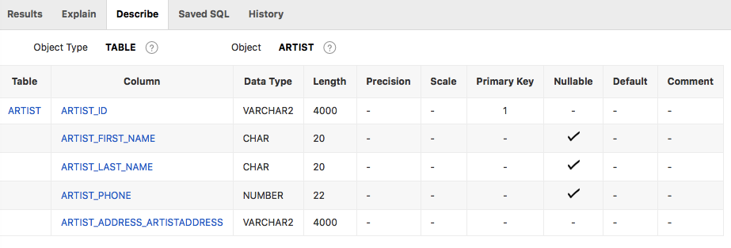

1. **Artist- Artwork Table**

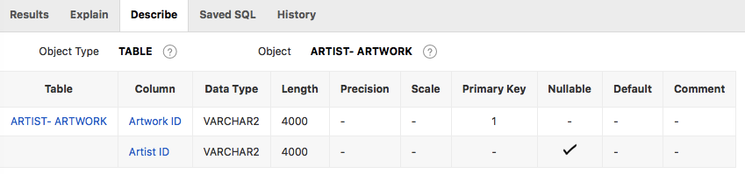

1. **Artist- Customer Table**

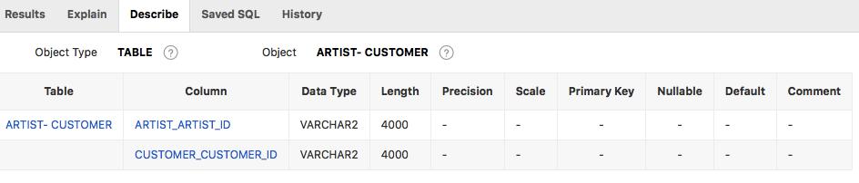

1. **Artwork Table**

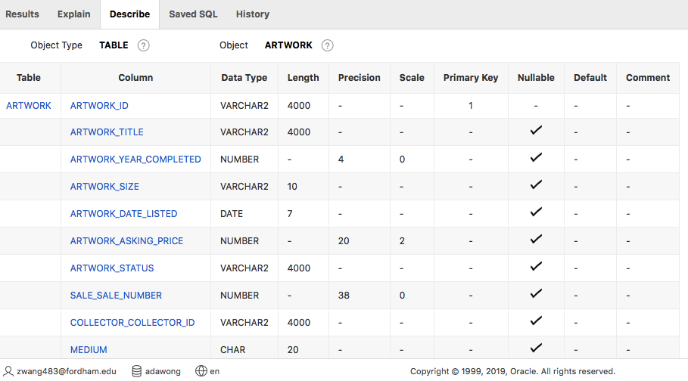

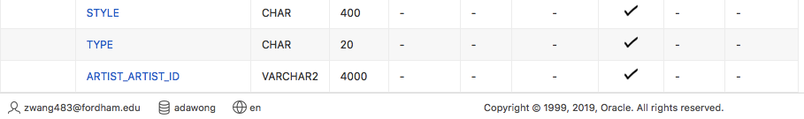

1. **Artwork-Sale Table**

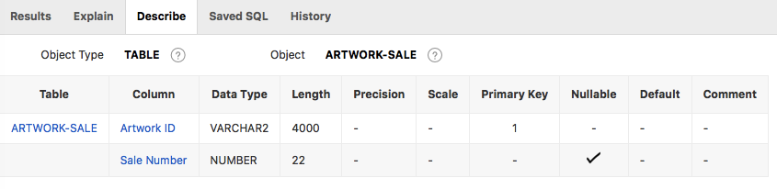

1. **Artwork-Show Table**

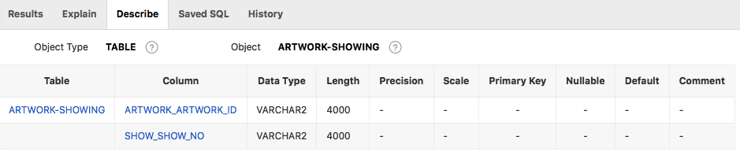

1. **Collector Table**

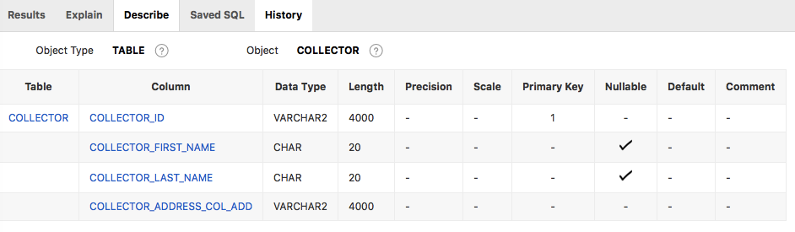

1. **Collector-Artwork Table**

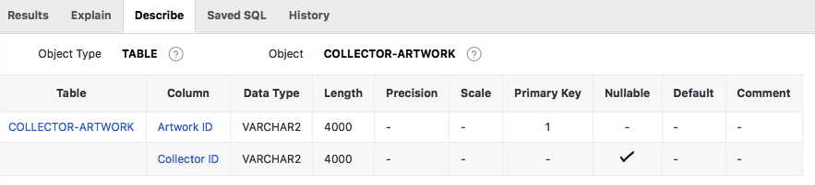

1. **Customer Table**

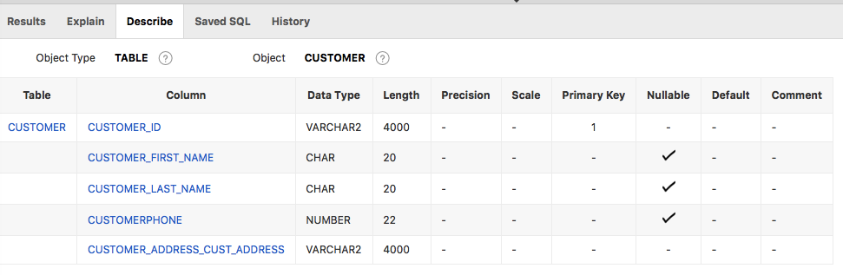

1. **Customer-Sale Table**

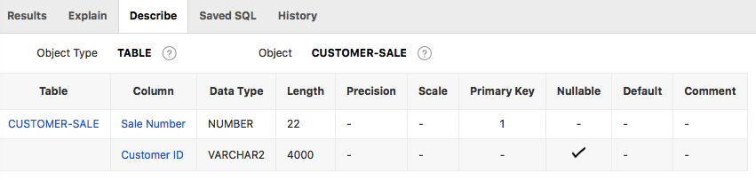

1. **Sale Table**

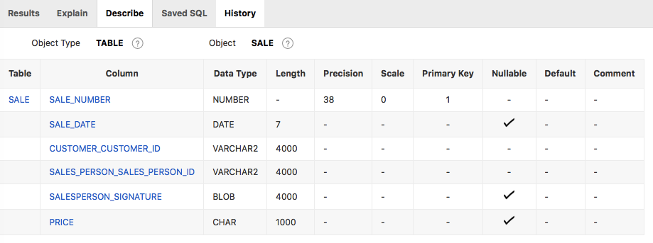

1. **Sale-Salesperson Table**

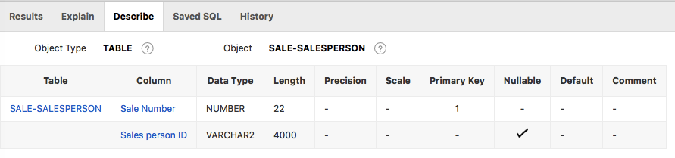

1. **Salesperson Table**

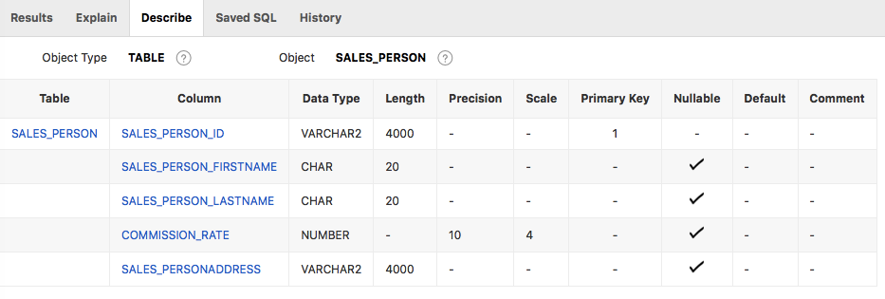

1. **Show Table**

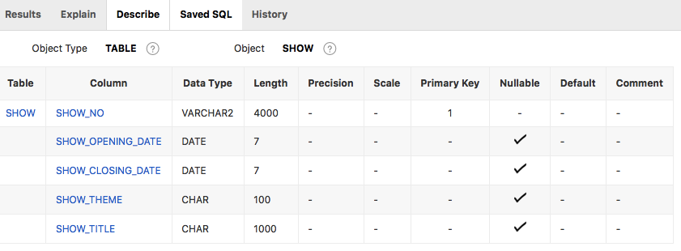

1. **Show2 Table**

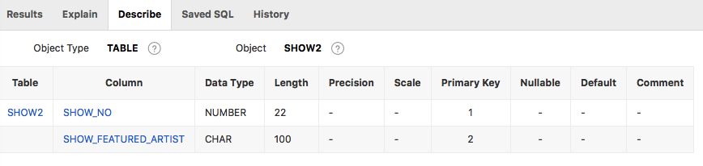

1. **Table with Data**
2. **Artist:**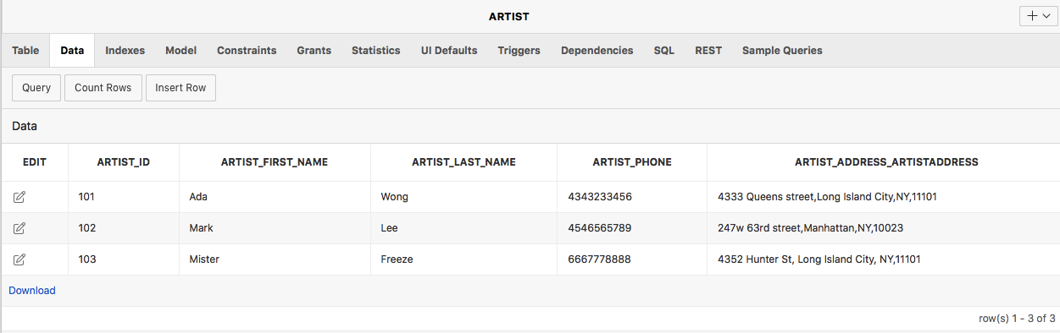
3. **Artist-Artwork:**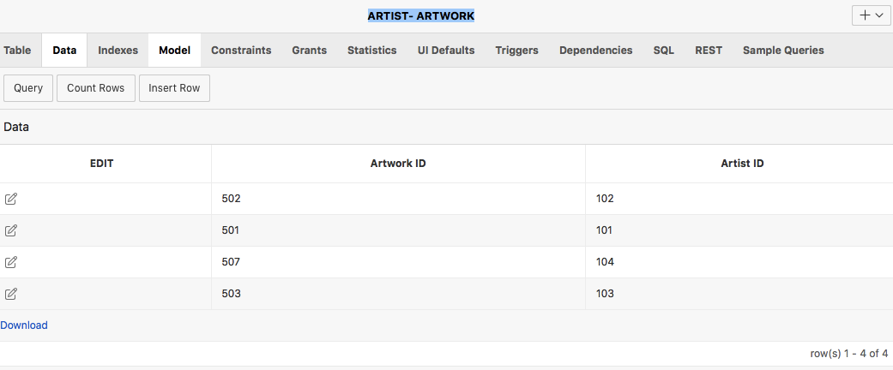
4. **Artist-Customer:**
5. **Artwork:**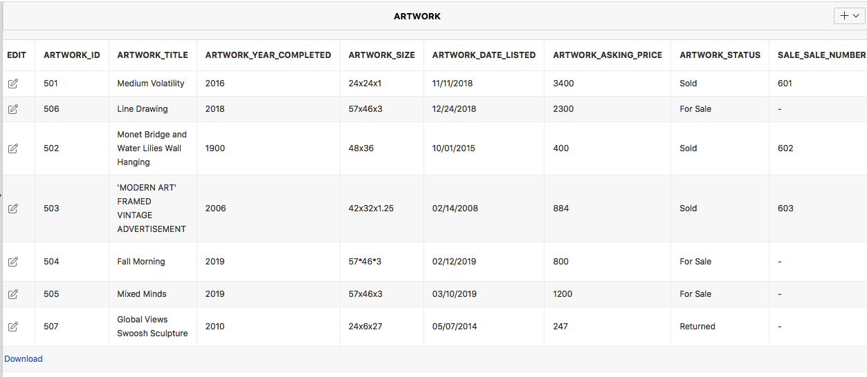

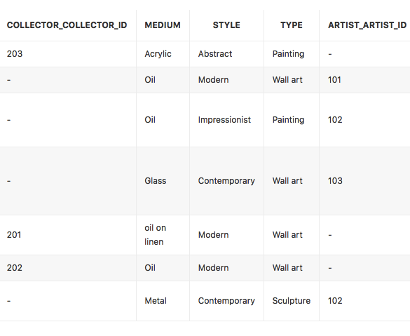

1. **Artwork-Sale:**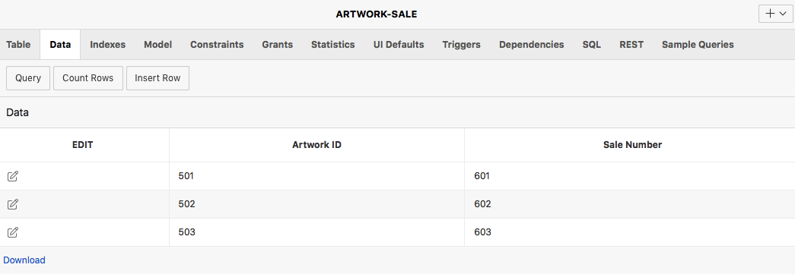
2. **Artwork-Showing:**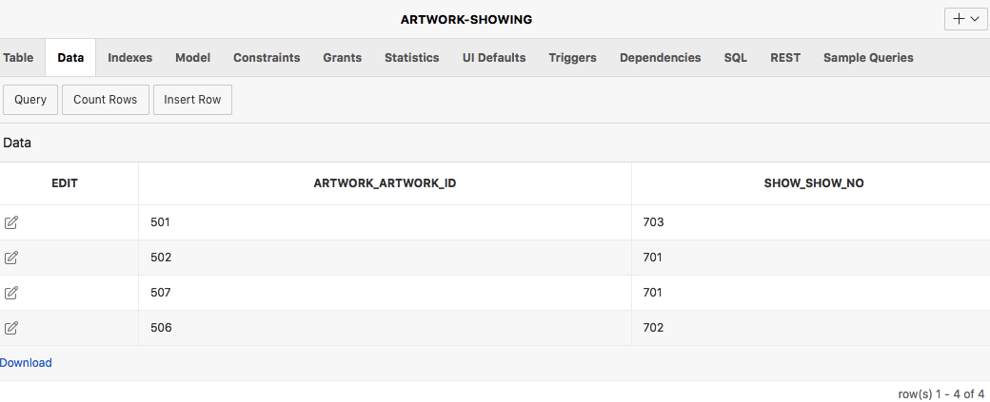
3. **Collector:**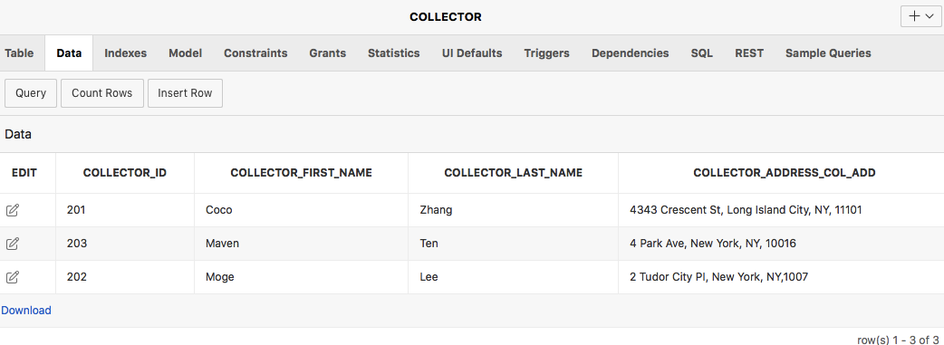
4. **Collector-Artwork:**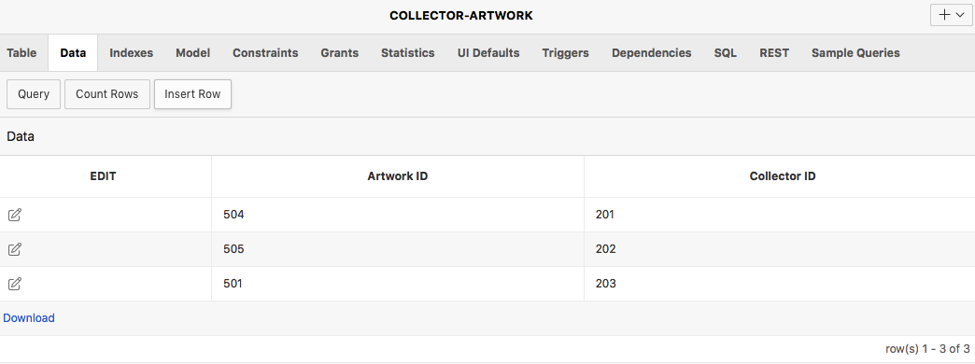
5. **Customer:**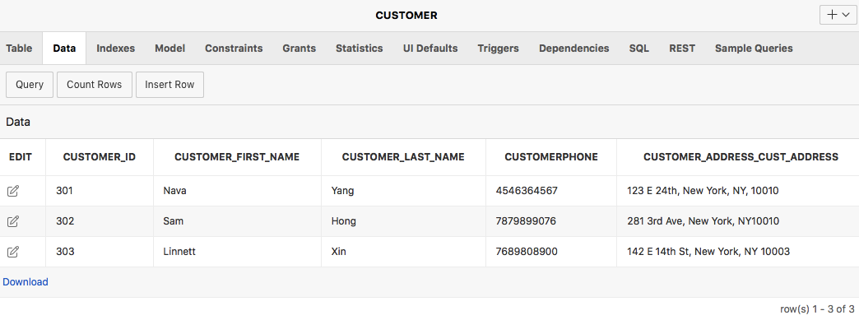
6. **Customer-Sale:**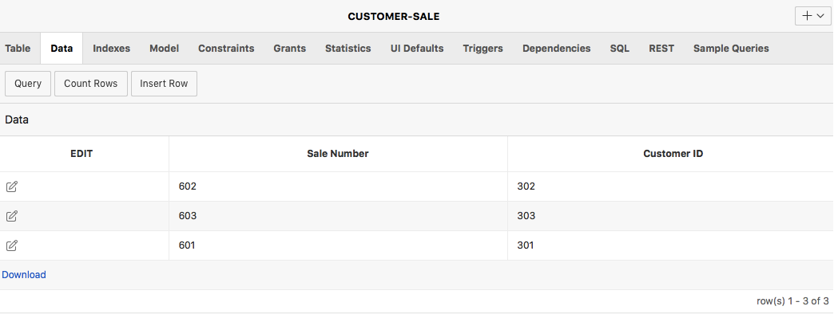
7. **Sale:**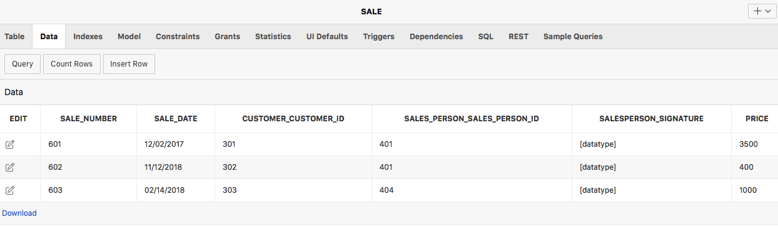
8. **Sale-Salesperson:**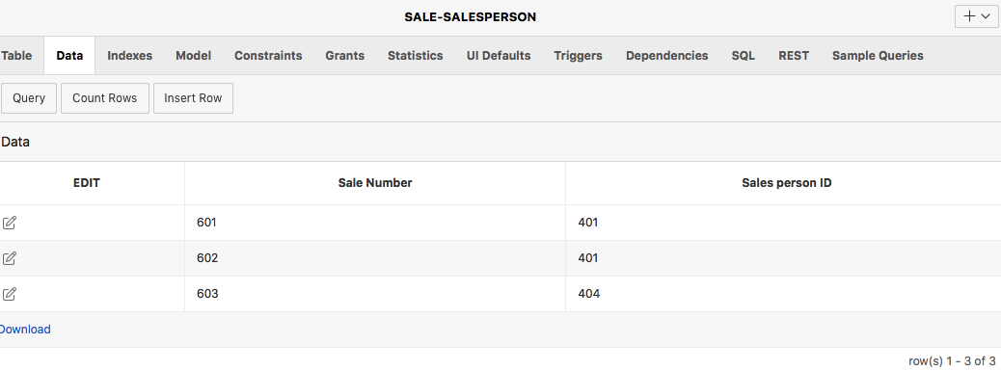
9. **Salesperson:**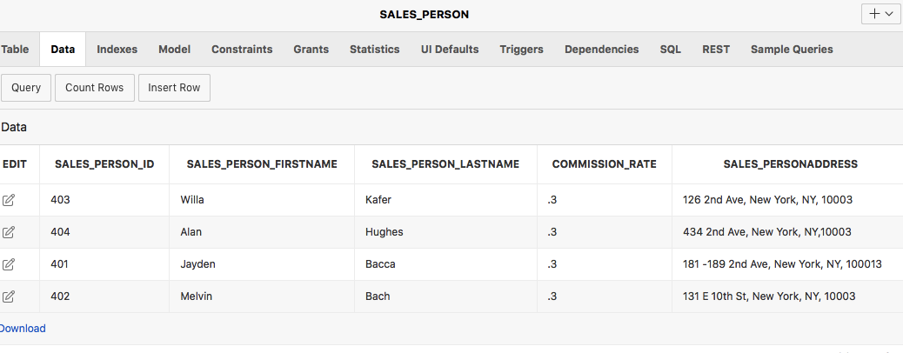
10. **Show:**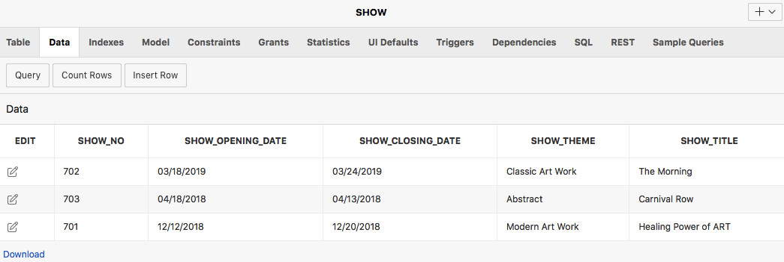
11. **Show2:**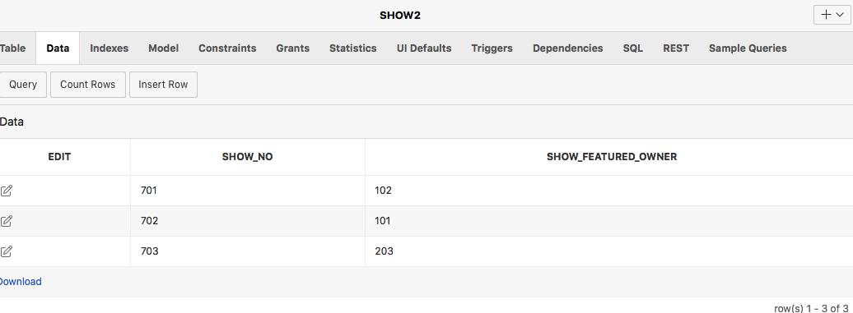

1. **12 Queries**
2. **English Version:** Who owns the artwork? his or her title ( artist or collector), full name, and address.
   1. **SQL Version:**

Select artwork_title, artist_first_name || artist_last_name as Artist_Name, ARTIST_ADDRESS_ARTISTADDRESS as Artist_Address, collector_first_name || collector_last_name as Collector_Name, COLLECTOR_ADDRESS_COL_ADD as Collector_Addresss

From artwork

left join artist

on artist.artist_id = artwork.artist_artist_id

left join collector

on collector.COLLECTOR_ID = artwork.COLLECTOR_COLLECTOR_ID

* 1. **Output:**

|  |  |  |  |  |
| --- | --- | --- | --- | --- |
| **Artwork_Title** | **Artist_Name** | **Artist_Address** | **Collector_Name** | **Collector_Address** |
| Fall Morning | **-** | **-** | Coco Zhang | 4343 Crescent St, Long Island City, NY, 11101 |
| Medium Volatility | **-** | **-** | Maven Ten | 4 Park Ave, New York, NY, 10016 |
| Mixed Minds | **-** | **-** | Moge Lee | 2 Tudor City PI, New York, NY,1007 |
| Line Drawing | Ada Wong | 4333 Queens street,Long Island City,NY,11101 | - | **-** |
| Monet Bridge and Water Lilies Wall Hanging | Mark Lee | 247w 63rd street,Manhattan,NY,10023 | **-** | **-** |
| 'MODERN ART' FRAMED VINTAGE ADVERTISEMENT | Mister Freeze | 4352 Hunter St, Long Island City, NY,11101 | **-** | **-** |
| Global Views Swoosh Sculpture | Mark Lee | 247w 63rd street,Manhattan,NY,10023 | **-** | **-** |

1. **English Version:** Give the information about the artwork title with related price, sale date, salesperson name and customer name.

**2.1. SQL Version:**

Select artwork_title, price, sale_date，sales_person_firstname || sales_person_lastname as Salesperson_name, customer_first_name || customer_last_name as customer_name

From artwork

left join customer

on artwork.customer_id = customer.customer_id

left join sale

on artwork.sale_sale_number = sale_number

left join sales_person sp

on sale.sales_person_sales_person_id = sp.sales_person_id

**2.2. Output:**

|  |  |  |  |  |
| --- | --- | --- | --- | --- |
| **Artwork_Title** | **Price** | **Sale_Date** | **Salesperson_name** | **Customer_name** |
| Medium Volatility | 3500 | 12/02/2017 | Jayden Bacca | Nava Yang |
| Line Drawing | - | - | - | - |
| Monet Bridge and Water Lilies Wall Hanging | 400 | 11/12/2018 | Jayden Bacca | Sam Hong |
| 'MODERN ART' FRAMED VINTAGE ADVERTISEMENT | 1000 | 02/14/2018 | Alan Hughes | Linnett Xin |
| Fall Morning | **-** | **-** | **-** | **-** |
| Mixed Minds | **-** | **-** | **-** | **-** |
| Global Views Swoosh Sculpture | **-** | **-** | **-** | **-** |

1. **English Version:** Give related sales information of artworks which are owned by collector.
   1. **SQL Version:**

Select artwork_title,collector_first_name || collector_last_name as collector_name,

SALES_PERSON_FIRSTNAME|| SALES_PERSON_lastname as Salesperson_name,sale.price，sale.SALE_DATE

From artwork

left join collector

on collector.COLLECTOR_ID = artwork.COLLECTOR_COLLECTOR_ID

left join sale

on artwork.sale_sale_number = sale_number

left join sales_person sp

on sale.SALES_PERSON_SALES_PERSON_ID=sp.SALES_PERSON_ID

* 1. **Output:**

|  |  |  |  |  |
| --- | --- | --- | --- | --- |
| **Artwork_Title** | **Collector_Name** | **Salesperson_Name** | **Price** | **SALE_Date** |
| 'MODERN ART' FRAMED VINTAGE ADVERTISEMENT | - | Alan Hughes | 1000 | 02/14/2018 |
| Medium Volatility | Maven Ten | Jayden Bacca | 3500 | 12/02/2017 |
| Monet Bridge and Water Lilies Wall Hanging | - | Jayden Bacca | 400 | 11/12/2018 |
| Fall Morning | Coco Zhang | - | - | - |
| Mixed Minds | Moge Lee | - | - | - |
| Line Drawing | - | - | - | - |
| Global Views Swoosh Sculpture | - | - | - | - |

1. **English Version:** Give the information about the artwork title with related artist name, customer name and show theme in exhibition.

**4.1. SQL Version:**

Select artwork_title, artist_first_name || artist_last_name as artist_name, customer_first_name || customer_last_name as customer_name, show_theme

From artwork

left join artist

on artist.artist_id = artwork.artist_artist_id

left join sale

on artwork.sale_sale_number = sale_number

left join customer

on sale.customer_customer_id = customer_id

left join show

on show_no = artwork.show_number

**4.2. Output:**

|  |  |  |  |
| --- | --- | --- | --- |
| **Artwork Title** | **Artist Name** | **Customer Name** | **Show Theme** |
| Medium Volatility | - | Nava Yang | Classic Art Work |
| ‘Modern Art’ Framed Vintage Advertisement | Mister Freeze | Linnett Xin | Classic Art Work |
| Monet Bridge and Water Lilies Wall Hanging | Mark Lee | Sam Hong | Abstract |
| Line Drawing | Ada Wong | - | Abstract |
| Fall Morning | - | - | Modern Art Work |
| Mixed Minds | - | - | Modern Art Work |
| Global Views Swoosh Sculpture | Mark Lee | - | Modern Art Work |

1. **English Version:** Give Tax of all sales and their related customer name.
   1. **SQL Version:**

Select sale.sale_number, customer.customer_first_name||' '||customer.customer_last_name

as customer_name, sale.price* 0.08875 as Tax

From sale, customer

Where customer.customer_ID=sale.customer_customer_ID

* 1. **Output:**

|  |  |  |
| --- | --- | --- |
| **SALE_NUMBER** | **CUSTOMER_NAME** | **TAX** |
| 601 | Nava Yang | 310.625 |
| 602 | Sam Hong | 35.5 |
| 603 | Linnett Xin | 88.75 |

1. **English Version:** Give artwork information including title, asking price and medium and their related artist name.
   1. **SQL Version:**

Select artwork_title, artwork_asking_price, medium, artist.artist_first_name||' '||artist.artist_last_name as artist_name

From ARTWORK, ARTIST

Where artist.artist_ID=artwork.artist_artist_ID

Order by artwork_asking_price desc

**6.2. Output:**

|  |  |  |  |
| --- | --- | --- | --- |
| **ARTWORK_TITLE** | **ARTWORK_ASKING_PRICE** | **MEDIUM** | **ARTIST_NAME** |
| Line Drawing | 2300 | Oil | Ada Wong |
| ‘MODERN ART’ FRAMED VINTAGE ADVERTISEMENT | 884 | Glass | Mister Freeze |
| Monet Bridge and Water Lilies Wall Hanging | 400 | Oil | Mark Lee |
| Global Views Swoosh Sculpture | 247 | Metal | Mark Lee |

1. **English Version:** Give commissions of all salespersons and their related sales
   1. **SQL Version:**

Select SALES_PERSON.SALES_PERSON_FIRSTNAME ||'

'|| SALES_PERSON.SALES_PERSON_LASTNAME as Salesperson_Name,

SALE.SALE_NUMBER,SALES_PERSON.COMMISSION_RATE,

sale.price* SALES_PERSON.COMMISSION_RATE as Commission

From sale,SALES_PERSON

Where SALES_PERSON.SALES_PERSON_ID=sale.SALES_PERSON_SALES_PERSON_ID

Order by Salesperson_Name

* 1. **Output:**

|  |  |  |  |
| --- | --- | --- | --- |
| **SALESPERSON_NAME** | **SALE_NUMBER** | **COMMISSION_RATE** | **COMMISSION** |
| Alan Hughes | 603 | 0.3 | 300 |
| Jayden Bacca | 601 | 0.3 | 1050 |
| Melvin Bach | 602 | 0.3 | 120 |

1. **English Version:** Give all price differences of artwork between selling and asking price
   1. **SQL Version:**

Select Artwork.ARTWORK_ID,

ARTWORK.ARTWORK_TITLE,ARTWORK.ARTWORK_ASKING_PRICE,

sale.price,(sale.price-ARTWORK.ARTWORK_ASKING_PRICE) as PRICE_DIFFERENCE

From Artwork, sale

Where artwork.SALE_SALE_NUMBER=sale.SALE_NUMBER

Order by Artwork.Artwork_ID

* 1. **Output:**

|  |  |  |  |  |
| --- | --- | --- | --- | --- |
| **ARTWORK_ID** | **ARTWORK_TITLE** | **ARTWORK_ASKING_PRICE** | **PRICE** | **PRICE_DIFFERENCE** |
| 501 | Medium Volatility | 3400 | 3500 | 100 |
| 502 | Monet Bridge and Water Lilies Wall Hanging | 400 | 400 | 0 |
| 503 | 'MODERN ART' FRAMED VINTAGE ADVERTISEMENT | 884 | 1000 | 116 |

1. **English Version:** show the information of artwork which has been sold and previously owned by artist and completed after 2000.

**9.1. SQL Version:**

SELECT ARTIST.ARTIST_ID , ARTWORK.ARTWORK_ID, ARTWORK.Artwork_Title, ARTWORK.Artwork_Year_Completed, SALE.PRICE

FROM ARTIST, ARTWORK,SALE

WHERE ARTWORK.Artwork_Year_Completed > 2000 AND ARTIST.Artist_ID = ARTWORK.ARTIST_ARTIST_ID AND ARTWORK.SALE_SALE_NUMBER = SALE.SALE_NUMBER

**9.2. Output:**

|  |  |  |  |  |
| --- | --- | --- | --- | --- |
| **ARTIST_ID** | **ARTWORK_ID** | **ARTWORK_TITLE** | **ARTWORK_YEAR_COMPLETED** | **PRICE** |
| 103 | 503 | 'MODERN ART' FRAMED VINTAGE ADVERTISEMENT | 2006 | 1000 |

1. **English Version:** Obtain the information of different style of artwork, involving price, Salesperson’s ID, and quantity.

**10.1. SQL Version:**

SELECT ARTWORK.STYLE, SALE.PRICE,SALES_PERSON.SALES_PERSON_ID, COUNT(*)

FROM ARTWORK, SALE,SALES_PERSON

WHERE ARTWORK.SALE_SALE_NUMBER = SALE.SALE_NUMBER AND SALES_PERSON.SALES_PERSON_ID = SALE.SALES_PERSON_SALES_PERSON_ID

GROUP BY ARTWORK.STYLE, SALE.PRICE, SALES_PERSON.SALES_PERSON_ID

**10.2. Output:**

|  |  |  |  |
| --- | --- | --- | --- |
| **STYLE** | **PRICE** | **SALES_PERSON_ID** | **COUNT(*)** |
| Abstract | 3500 | 401 | 1 |
| Contemporary | 1000 | 404 | 1 |
| Impressionist | 400 | 401 | 1 |

1. **English Version:** Give information of Artworks that are not on show
   1. **SQL Version:**

Select ARTWORK_ID, ARTWORK_TITLE, ARTWORK_DATE_LISTED,ARTWORK_ASKING_PRICE

From ARTWORK

Where ARTWORK_ID not in (

Select ARTWORK_ARTWORK_ID

From "ARTWORK-SHOWING" )

Order by ARTWORK_DATE_LISTED

* 1. **Output:**

|  |  |  |  |
| --- | --- | --- | --- |
| **ARTWORK_ID** | **ARTWORK_TITLE** | **ARTWORK_DATE_LISTED** | **ARTWORK_ASKING_PRICE** |
| 503 | 'MODERN ART' FRAMED VINTAGE ADVERTISEMENT | 2/14/08 | 884 |
| 504 | Fall Morning | 2/12/19 | 800 |
| 505 | Mixed Minds | 3/10/19 | 1200 |

1. **English Version:** give all the information of artist whose artwork has been sold, containing artist ID, artwork ID, artwork title, artwork size and artwork asking price

**12.1. SQL Version:**

SELECT ARTIST.Artist_ID ,ARTWORK.Artwork_ID, ARTWORK.Artwork_Title, ARTWORK.Artwork_Size, ARTWORK.Artwork_Asking_Price

FROM ARTIST

JOIN ARTWORK

ON ARTIST.Artist_ID = ARTWORK.Artist_Artist_ID

ORDER BY Artist_ID

**12.2. Output:**

|  |  |  |  |  |
| --- | --- | --- | --- | --- |
| **ARTIST_ID** | **ARTWORK_ID** | **ARTWORK_TITLE** | **ARTWORK_SIZE** | **ARTWORK_ASKING_PRICE** |
| 101 | 506 | Line Drawing | 57x46x3 | 2300 |
| 102 | 507 | Global Views Swoosh Sculpture | 24x6x27 | 247 |
| 102 | 502 | Monet Bridge and Water Lilies Wall Hanging | 48x36 | 400 |
| 103 | 503 | 'MODERN ART' FRAMED VINTAGE ADVERTISEMENT | 42x32x1.25 | 884 |

1. **Screenshot of database**

